

TQA Charter Automation
Quality Management Plan
Version 1.4
Classification: Internal
Document Owner: Gagandeep Singh

© Xavient Information Systems
This document contains the confidential and proprietary information of Xavient Information Systems, the disclosure of which would provide a competitive advantage to others. As a result, no part of this document should be disclosed, used, duplicated, reproduced, stored, copied, or transmitted, in whole or in part, in any form or means, electronic, mechanical, photocopying or otherwise without the express consent of Xavient Information Systems. This document shall remain the property of Xavient Information Systems.
This restriction does not limit the rights of the recipient to use information contained within the document if it is rightfully obtained from the source without restriction. The data subject to this restriction are contained in the entire document

Xavient Information Systems
2125 C Madera Road; Simi Valley, C.A 93065.
Main Line: 1.805.955.4111, Fax Line: 1.805.955.4144 Visit Us: www.xavient.com

Version Summary

Version No. | Prepared By | Reviewed By | Approved By | Release Date
1.0 | Gagandeep Singh | Mohd Khalid Taha | Mohd Khalid Taha | 08-Jan-2013
1.1 | Gagandeep Singh | Mohd Khalid Taha | Mohd Khalid Taha | 07-Jan-2016
1.2 | Rashid Mustafa | Gagandeep Singh | Mohd Khalid Taha | 01-Jun-2016
1.3 | Abhishek Gola | Nishant Kumar Yadav | Mohd Khalid Taha | 27-Feb-2017
1.4 | Syed Mazhar Nadir | Nishant Kumar Yadav | Mohd Khalid Taha | 14-June-2017

Modification Details

Version No. | Release Date | Description Of Change (if any)
1.0 | 08-Jan-2013 | Initial Draft
1.1 | 07-Jan-2016 | Updated Quality Tools Used Section
1.2 | 01-April-2016 | Reviewed and updated as required.
1.3 | 27-Feb-2017 | Reviewed and updated as required.
1.4 | 14-June-2017 | Reviewed and updated fields as required.
1.5 | 21-July-2017 | Reviewed all the sections and updated as required.

Table of Contents
1. Purpose 3
2. Quality Management Approach 3
3. Quality Requirement & Planning 4
3.1 Quality Baseline 5
3.2 Define Project Quality Metrics 5
3.3 Process Improvement Plan 6
3.4 Quality Checklist 7
4. Quality Analysis and Control 8
5. Quality Assurance 9
6. Roles and Responsibility 10
7. Automation Tools used for Development 11

- Purpose
The Project Quality Management Plan documents the necessary information required to effectively manage project quality from project planning to delivery. It defines a project’s quality policies, procedures, criteria for and areas of application, and roles, responsibilities and authorities.
- Supporting Automation development & implementation the Automation process correctly
- The plan incorporates
  - Quality Assurance and Control process
  - Effective software engineering practices (methods and tools)
  - Control of all Automation Development activities and changes made
to them
  - Measurement and Reporting mechanisms
  - Consistent & Continuous Improvement Process
- Quality Management Approach
The Project Quality Management Approach will be defined during the Planning Phase of the project and depicts any specific approach needs to be followed.
The intended audience for Quality Management Plan is the project manager, project team, project sponsor and any senior leaders whose support is needed to carry out the plan.
Following is the Quality Management Approach to be followed across the organization
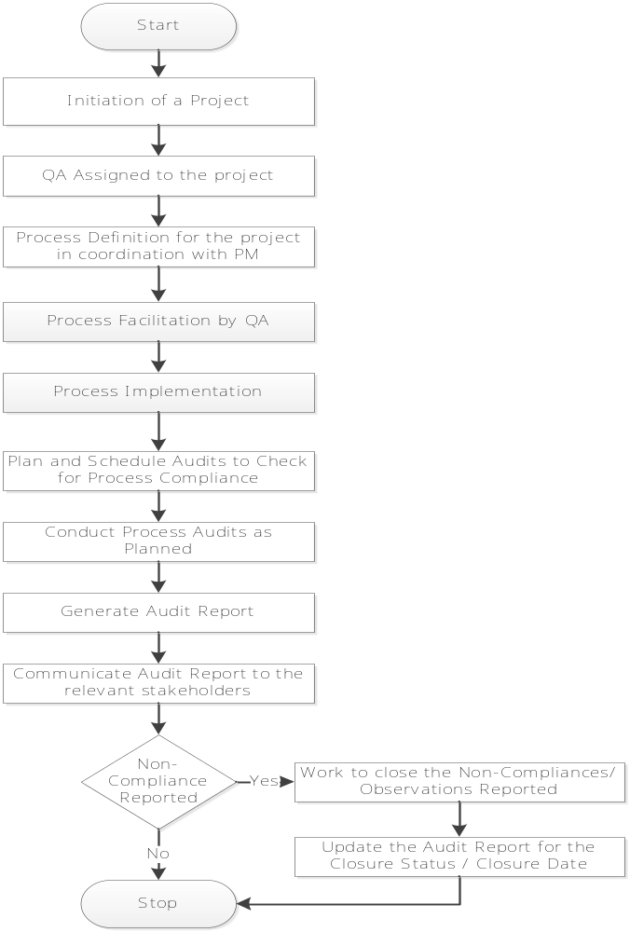

- Quality Requirement & Planning
Following are the quality standards that are applicable to and are been followed in this project:-
- CMMI for Development Constellation Version 1.3
- ISO 27001
- PCI DSS Standards
Process definition and implementation for the same will be done on the standards defined above. Quality Audits will be scheduled and conducted to check for the process compliance against the defined standards.

Outputs:
- Quality Baseline
- Quality Metrics
- Process Improvement Plan & Techniques
- Quality Checklist
- Updates to Project Management Plan

Quality Baseline
Quality Baseline records the software’s established quality objectives and quality metrics with actual quality achieved in the project. Quality Baseline will include but not be limited to the following:
- Documentation standards – Internally developed documents will conform to the project’s Document Management procedures
- Testing standards and practices – Testing of all system components is the responsibility of the Project Team and testers. The tester is expected to conduct testing based on testing standards. Test plans, Automation test scripts, procedures, scenarios, and results are expected to be developed and presented in a consistent manner and in accordance with the standard including Peer Review & Formal Technical Review.
- Quality Assurance Reviews – The process for reviewing key product deliverables, how quality. The standards usually define the processes and procedures for organizational activities and assist to maintain the quality in every aspect of organizational functioning
- Define Procedures – Verify that there are clearly defined procedures in place to address discrepancies and uncertainties or variables in test data.

Define Project Quality Metrics
Following are the quality metrics that will be created and maintained in this project:-
- Schedule Variance – Schedule variance is the variation in the planned and the actual schedule. Schedule variance can be either positive or negative. When the task gets completed before the planned date of completion, there is a negative variance. When the task gets completed after the planned date of completion, there is a positive variance. It is recommended that schedule variance should be zero or within the acceptable threshold value.
- Effort Variance – Effort variance is the variation in the planned and the actual schedule. Schedule variance can be either positive or negative. When the task gets completed in less than the planned effort, there is a negative variance. When the task gets completed in more than the planned effort, there is a positive variance. It is recommended that effort variance should be zero or within the acceptable threshold value.
- Rework Effort – Any effort spent on (Code review bug fixes effort + Unit testing bug fixes effort + TQA bug fixes effort) can be considered as rework effort. Team should always plan and work in a way which minimizes rework effort.
- Defects reported in TQA, Defects Closure percentage – Defect closure percentage should be high. Higher defect closure percentage signifies the closure of more defects which results in the better quality of the product
- Defects Reopened Percentage – This metrics depicts the percentage of defects that are rejected by the developers or the defects which are not considered to be defects. Defect rejection percentage should be low. In case defect rejection percentage goes high, that means the TQA team is not clear on the requirements to be tested.
- Test Execution Rate – Test Execution Rate is the variation in the planned and the actual test execution. Test Execution rate can be either high or low. When the task gets completed before the planned date of completion, other automated regression activities needs to be kicked off. When execution is performed without roadblocks the rate will be high else it might be lower than SLA.
- Defect Efficiency – This metrics depicts the percentage of defects that are missed by testers or the defects that exist in first week of production. Defect Efficiency percentage should be 100%. In case defect efficiency <100%, that means the TQA team need to focus more on requirements to be tested.

Process Improvement Plan
The project establishes quality improvement strategies based on the value of each improvement with respect to the project’s objectives. Improvement strategies are determined on such measures as time to recover the cost of the improvement, improvement in project performance and the project’s ability to respond to the changes. Selected quality improvements will be managed and controlled through the project’s established change control process.
The actual deployment of quality improvements will be carried out in a controlled and disciplined manner. Steps to support actual quality improvement may include:
- It is important to identify the level of experience and skills for each of your team members and divide your automated testing efforts accordingly.
- Create automated tests that are reusable, maintainable and resistant to changes in the applications UI and Web Services.
- Generate Weekly and Monthly (periodically) testing report to get true picture of testing activities like Bug Find Rate, Effort Variance, Test Case Effectiveness, Residual defect density, Schedule Variance, etc.
- Providing updated training materials to reflect the improvements to the project’s procedures, guidelines, plans, process and technology.
- Providing consultation support.
- Documenting and reviewing the results of the deployment and prepare MOM for that
- Identifying and documenting lessons learned.
- Revisiting process and product improvement measures, objectives, priorities, and deployment plans as necessary.
- Measuring the effects of the deployed process improvements.
- Measuring the actual cost, effort, and schedule for deployment of each improvement.
- Measuring the value of each process improvement.

Quality Checklist
Quality Checklist is a structured tool in graph or table form used in a project to verify that a set of required steps are performed to maintain quality of Automated Scripts. Here are some of the checklists we follow.
 | Verification
Quality Item | Yes | No | N/A | Comments
Does the project have an approved quality management plan?
Has the quality management plan been reviewed by all stakeholders?
Do all stakeholders have access to the quality management plan?
Is the quality management plan consistent with the rest of the overall project plan?
Have product quality metrics been established, reviewed, and agreed upon?
Have process quality metrics been established, reviewed, and agreed upon?
Do all metrics support a quality standard which is acceptable to the customer?
Do all metrics have agreed upon collection mechanisms?
Do all metrics have an agreed upon collection frequency?
Have quality metrics review meetings been scheduled throughout the project's duration?
Are all metrics clear, measurable, controllable, and reportable?
Is the project team familiar with the project's quality review process?
Does the project have an appropriate number of resources assigned for quality assurance and control?
Has the project team established a repository for all quality documentation?
Do all team members have access to the quality documentation repository?
Have all appropriate team members been notified of their required participation in quality reviews?
Have quality responsibilities been assigned and documented and the applicable personnel notified?
Have product and process quality standards been established, documented, and communicated?
Have quality thresholds and limits been established, documented, and communicated?
Does the change control process accommodate project changes based on quality improvements?
Has a project quality manager been assigned?
Is the project sponsor aware of his/her responsibilities relating to quality acceptance?
Is the customer aware of his/her responsibilities relating to quality acceptance?
Does the code do what has been specified in the design specification?
Does the procedure used in the module solve the problem correctly?
Will you be running the same tests on multiple Regression Releases and configurations
Does each module have a single entry point and a single exit point?
It is important to adhere to coding standards to ease the introduction of a new contributor (programmer) to the development of a system.
Has the code been adequately commented upon?
Have all the variables and constants been correctly initialized?
Have correct types and scopes been checked?
Are the global or shared variables, if there are any, carefully controlled?
Are there data values hard coded in the program?
Rather, these should be declared as variables.
Is there a possibility of an infinite loop, a loop that never executes, or a loop with a premature exit?
Have all the files been opened for use and closed at termination?
Are error codes and condition messages produced by accessing a common table of messages?
Code review is intended to detect implementation choices that have adverse effects on system performance
Is the possible exit criteria matched actually

- Quality Analysis and Control
Quality control involves operational techniques meant to ensure quality standards. This includes identifying, analyzing, and correcting problems. While quality assurance occurs before a problem is identified, quality control is reactionary and occurs after a problem has been identified. Quality control monitors specific project outputs and determines compliance with applicable standards. It also identifies project risk factors, their mitigation, and looks for ways to prevent and eliminate unsatisfactory performance.
Quality Control is performed to identify following objectives in software process
- Incomplete or erroneous or Intentional deviation specifications
- Errors or Misinterpretation in data representation
- Inaccurate or incomplete documentation
- Ambiguous or inconsistent human/computer interface
Process
Quality control is done to identify below flaws in software process
- Involves a series of inspections, and reviews used throughout the software process
- Ensures that each work product meets the requirements placed on it
- Includes a feedback loop to the process that created the work product
- Combines measurement and feedback in order to adjust the process when product specifications are not met
- Requires all work products to have defined, measurable specifications to which practitioners may compare to the output of each process
Outputs:
- Acceptance Decisions
- Quality Control Measurements
- Non Conformance Identification & Rework
- Corrective and Preventive Actions
- Change Identification
- Updates to Organizational Process
- Updates to Project Management Plan
- Quality Assurance
Quality assurance tests use a system of metrics to determine whether or not the quality plan is proceeding in an acceptable manner. By using both qualitative and quantitative metrics project quality is measured with respect to customer satisfaction. Quality audits will help to predict and verify the achievement of goals and identify need for corrective actions. Additionally, quality assurance tests help in mapping quality metrics to quality goals, allowing reporting on status of quality at periodic project review meetings. Quality Assurance is performed to identify following objectives in software process and key elements:
- Measure each existing process and its output to determine current quality performance
- Define customer requirements, deliverables, and project goals via well-defined methods of customer communication.
- Follow Standards – ensure that applied standards should be adopted and followed
- Reviews and audits – audits are reviews performed by SQA personnel to ensure that quality guidelines are followed and met for all Automation Development projects
- Testing – ensure that testing must be properly planned and conducted
- Error/defect collection and analysis – collects and analyses error and defect data to better understand how errors are introduced and can be eliminated
- Changes management – ensures that adequate change management practices have been instituted
- Quality assurance systems are defined as the organizational structure, responsibilities, procedures, processes, and resources for implementing quality management.
- Education – takes lead in software process improvement and educational program
- Security management – ensures use of appropriate process and technology to achieve desired security level
- Safety – responsible for assessing impact of software failure and initiating steps to reduce risk
- Risk management – ensures risk management activities are properly conducted and that contingency plans have been established

- Roles and Responsibility

S# | Role identified | Key Responsibilities
1 | Project Manager | - Manage Project delivery.  - Client Management and manage escalations.  - Manage Resource requirement at offshore.  - Manage offshore resources.  - Provide update to Offshore Management.
2 | Onsite Coordinator | - Client Communication on a daily basis.  - Work identification for offshore resources after  Discussion with client.  - Coordinate delivery with PL and offshore TL.  - Report to offshore PM and client Manager.  - Review offshore work on daily basis.  - Daily, Weekly and Monthly meetings with the teams.
3 | Project Lead | - Lead and manage offshore team on technical front.  - Review offshore team deliverables.  - Monthly, Weekly team meetings.  - Manage client communication, meetings and calls.  - Manage daily, weekly and monthly status reports,, Timesheets Management.  - Process improvement and implementations.  - Report to offshore and Onshore PM.  - Recruitment of Offshore and Onshore team members.  - Involved in Onboarding/Off-boarding of Offshore resources.  - Training and skill set improvements.
4 | Team Lead | - Client/Onshore Communication on a daily basis.  - Work identification for offshore resources after  Discussion with client.  - Shifts planning as per project requirements.  - Coordinate delivery with PM and offshore TL.  - Report to offshore PL and Onshore POCs.  - Training planning and execution for new joiners in team.  - Review offshore work deliverables.  - Preparation of Monthly, Weekly and Daily reports.
5 | Associate Team Lead | - Client/Onshore Communication on a daily basis.  - Work identification for offshore resources after  Discussion with client.  - Report to offshore TL and Onshore POCs.  - Conduct training and assessment process for new resources.  - Cross training of resources within projects.  - Review offshore work deliverables.  - Involved in process improvement and documentation update.
6 | Senior Software Test Engineer | - Co-ordinate with offshore team  - Work on Deliverables  - Assign Tasks to team  - Perform Requirement Analysis  - Test Case Creation/updation  - Query Handling  - Defects Triage calls handling
7 | Software Test Engineers | - Understand Requirement  - Test case/scripts creation/update  - Test Cases review  - Prepare Test Data- Do test execution  - Defects Management  - Responsible for pair training.
8 | Associate Software Test Engineers | - Understand Requirement  - Scenario creation/update  - Test case/scripts creation/update  - Prepare Test Data  - Defects Management
9 | Trainee | - Understand Requirement  - Prepare Test Data  - Test Data cleanup  - Attends Training & KT session  - Supporting team leads in their day to day work.

- Automation Tools used for Development
Tool | Description
HP ALM | This tool is used for test management
UFT | This Tool is used for Functional Testing against the periodically Regression Functional Testing
Selenium | This Tool is used for Developing our Automated Scripts into Selenium Java tool
SOAP UI | This tool is used for web services testing

Major software requirements of this project are:
- ALM 11.52
- UFT/QTP
- MS Office & MS Outlook
- IE or any other standard browser
- Antivirus/Spyware, as provided by organization
- SQL Developer
- Genband/Nortel/Safari
- CSG/Citrix Client
- Acision
- Sonus
- MetaSwitch
- UIM/Sigma
- Order Manager/OSM
- Neustar Application
- APS

